Table of Contents

1.Configure table and column properties 2

1.1 Table properties. 2

1.2 Column properties 6

2.Implement role-playing dimensions 9

3.Define a relationship's cardinality and cross-filter direction 9

4.Create a common date table 10

4.1 Common date table with DAX 10

4.2 Common date table with Power query 11

5.Identify use cases for calculated columns and calculated tables 11

6.Create single aggregation measures 12

6.3 Measures 12

7.Use the CALCULATE function 16

8. Implement time intelligence measures 18

9.Use basic statistical functions 22

10. Create semi-additive measures 25

11. Create a measure by using quick measures 27

12. Create calculated tables or columns 29

13.Create calculation groups 31

14.Improve performance by identifying and removing unnecessary rows and columns 33

15.Identify poorly performing measures, relationships, and visuals by using Performance Analyzer and DAX query view 35

16. Improve performance by reducing granularity 35

# 1.Configure table and column properties

## 1.1 Table properties.

You can configure the table properties in the model view or in the data pane in report view .

It will allow you to rename the model , hidden model .

If you want to put description or synonym, you should go to the model view .

We have row label and key column and after we will have to choose the storage mode .

It is also possible to create folder you should just select a column and go to property .

You put the display folder name and you can create a folder with some column or measure in it.

You can also hide in the model view .

The DateTable has disappear.

You can also mark date as table

It will create this by default if you have a date column.

## 1.2 Column properties

There are many column properties that you can set. Like with tables, you can set the name, description, synonyms, and "is hidden" properties. It's common to hide columns that are used by relationships, especially when they're based on aren't meaningful key values.

Column names must be unique within the model table, and if the column is visible, you should set a user-friendly name. If you change the column name in Power BI Desktop, a new step is appended to the Power Query query to modify the column name there.

You can assign columns to a display folder, which helps organize the fields for a table. Consider using display folders when your table comprises many visible fields.

It is the same as above but more focused on column.

You can set up format , data type ,

It is feature related to how the data is formatted and presented .

You can sort by , categorize data and summarize.

# 2.Implement role-playing dimensions

Role-playing dimensions are used when you have multiple relationships between a fact table and a dimension table, often for different purposes or contexts. A classic example is the Date dimension used in multiple roles, such as Order Date, Ship Date, and Due Date.

You will have some connection which will be used multiple time and will be inactive but you will be able to use it thanks to the Dax query: USERELATIONSHIP ()

# 3.Define a relationship's cardinality and cross-filter direction

The cardinality is simple in Star schema, dimension 1 🡪 many to the fact table, concerning the cross filter it will use in function of need to retrieve or not the data from the dimension. In general, it will be one single but cross filter when you need to retrieve data based on the dimension or you need for RLS.

It is important to notice that the cardinality 1 to many allow to use the dimension as filter and the fact as aggregate so you will have just to use Single direction.

It give you the direction of the relationship from right to left.

If you want to know the number of locations by commune no soucis but if you want to know the number of commune by price, it will not be possible.(as you can see below)

If you want to be able to see this, you will have to enable Both cross filter direction.

After enabling , you finally have the number of commune with this price .

# 4.Create a common date table

You can create a common date table with several ways, import a date table , or create with dax functions a table with date or with power query .

Calendarauto(6)

It will create to end of June so July.

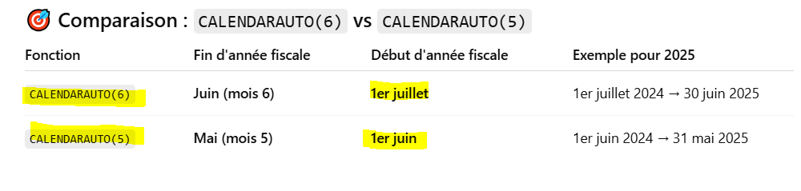

or calendar (date(),date())

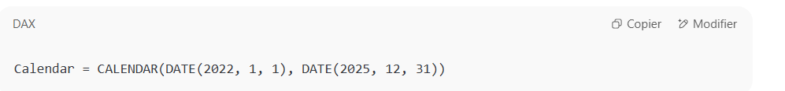

## 4.1 Common date table with DAX

Date= CALENDARAUTO (fiscalendyearmonth), it will automatically take the max and min from the other semantic model .

At the end mark the table as date table .

## 4.2 Common date table with Power query

# 5.Identify use cases for calculated columns and calculated tables

With DAX you can create calculated columns, tables and measures.

Table, you can use for example in the date common table. Columns you can created it for computation .

# 6.Create single aggregation measures

## 6.3 Measures

You can write a DAX formula to add a measure to any table in your model. The formula achieves summarization over model data. Like a calculated column, the formula must return a single value. However, unlike calculated columns, which are evaluated at data refresh time, measures are evaluated at query time. Their results are never stored in the model.

In the **Data** pane, measures are shown with the calculator icon. The following example shows three measures in the Sales table: Cost, Profit, and Revenue.

Occasionally, measures can be described as ***explicit measures***. To be clear, explicit measures are model calculations that are written in DAX and are commonly referred to as simply *measures*. Yet, the concept of *implicit measures* exists, too. **Implicit measures** are columns that can be summarized by visuals in simplistic ways, like count, sum, minimum, maximum, and so on. You can identify implicit measures in the **Data** pane because they're shown with the sigma symbol (∑).

Example implicit measure:

Dax formulas can be under several forms:

The result is also under various formats.

Dax is like programming language as python, Java etc. with his own syntax

6.3.1 Create new measure :

You can right-click on data pane or go in report view > table tools and select new measure.

Function in dax is also very used in order to create summarized data notably calculate function .

Measures are not physically stored as Calculated column !

# 7.Use the CALCULATE function

You can use it to compute but also filter data at the same time we will use it several times .

It is important to highlight that Calculate return a scalar value !

First expression is a measure after you have a filter , in the filter you can use logical operator , function etc...

Example:

I want to calculate the revenue YOY between in 2018 based on 2017.

I will start to create Calculate revenue from last year.

I will calculate the sum of revenue of the same period last year .

I can reuse some measures, i will just create new measure and substract with arithmetic operator .

It is good and infinity is normal because when you divide by 0 , it becomes infinite.

# 8. Implement time intelligence measures

Time intelligence relates to calculations over time. Specifically, it relates to calculations over dates, months, quarters, or years, and possibly time. Rarely would you need to calculate over time in the sense of hours, minutes, or seconds.

In Data Analysis Expressions (DAX) calculations, time intelligence refers to *modifying the filter context for date filters*.

It exists several functions, but we will use some of them .

We will use some of Dax time intelligence functions in order to calculate total year to date revenue but also new sales for a specific month.

it produces a summarization of the revenue amounts from the beginning of the year through to the filtered month.

As you can see every 30-04 (May) it reset and do a kind of sum cumulated.

Now we will start to compute new sales.

Another use of time intelligence functions is to count new occurrences. The following example shows how you can calculate the number of new sales for a period. A new sale is counted in the time period in which they made their first purchase.

It will compute the distinct sales [order id].

If you want to compute new sales compared to month before , you should subtract and use min as Elem of comparison .

It is done in the Microsoft learning example :

# 9.Use basic statistical functions

We will use basic statistical function that you can find in quick measure .

# 10. Create semi-additive measures

Semiadditive measures, which do not uniformly aggregate across all dimensions, are very common in many business scenarios. Every cube that is based on snapshots of balances over time exhibits this problem. You can find these snapshots in applications dealing with securities, account balances, budgeting, human resources, insurance policies and claims, and many other business domains.

You will just use function in filter calculate first and last date in order to avoid in the matrix total with data aggregate it is used for stock and account balance.

The formula first finds the last date to use, by finding the last date for which there is any data in the model. It then applies it as a filter

# 11. Create a measure by using quick measures

To create quick measure you just go to the report page , in home ribbon , you will find quick measure , click on it .

You choose between several computations.

You should be careful it allows only aggregate measure in base value.

# 12. Create calculated tables or columns

Calculated table or columns with DAX .

For calculed table see (Date table ).

For column very easy !

You can create calculated columns easily and put conditional in it .

We will for example create a conditional column and flag if the condition is fulfilled , we will create also **Monthkey , full date label and detect quarter with if .**

1. I will create a column who will detect stock > 1 and put Good stock, else Not good stock.

1. It will add a label FY to the delivery date year

1. Add monthkey for delivery date

# 13.Create calculation groups

Calculation groups can significantly reduce the number of redundant measures you have to create, by allowing you define DAX expressions as calculation items that apply to the existing measures in your model. More information about calculation groups is available in the [Calculation groups](https://learn.microsoft.com/en-us/analysis-services/tabular-models/calculation-groups) article.

You can create measure and just put it in the model and reuse them in your future measure.

# 14.Improve performance by identifying and removing unnecessary rows and columns

It is subdivided into 3 points dax measure , reduce model size and reduce level of cardinality (the more efficient power bi will be ).

We will focus now on low level of cardinality .

The 2 columns have the same size but data in column 1 has a lower cardinality because , 2 values and the column 2 has 6 values so column 1 has lower cardinality in comparison to column 2 .=> Better performance.

How to ensure low level of cardinality ?

You should have the correct data type in each columns ,(Some data types are not efficiently stored in comparison with other(s)) for example date/time consume most place than date (alone), it reduces the level of cardinality. Decimal 🡪 to whole number reduce the level of cardinality

Delete unnecessary column and rows

Avoid repeated values .

Summarizing data will decrease the level of cardinality and smaller model size.

We could also use measure instead of numerical column for example you have revenue computed for each row , but you can compute it with iterator function (dax) in power bi instead of stored this data.It will reduce the data cardinality.

You can find all this information thanks to Power query :

And analyze data that you want to keep or delete etc... (see chapter Get data)

# 15.Identify poorly performing measures, relationships, and visuals by using Performance Analyzer and DAX query view

You can use performance analyser to improve the performance of you dax .

You have to closed and open blank page , after go to ribbon homepage . (Because there is cache with data already stored and it will impact the performance analyzer).

After you click on start recording .

# 16. Improve performance by reducing granularity

The cardinality is the number of distinct value in the column.

It could be reduce by several ways , for example changing the type of data if you have date/time to Date alone .

We can also summarize the data in order to reduce the cardinality .

Question exam failed :

